COSC 2440 – Computer Organization and Architecture – Spring 2020 - Kevin B Long

# 

# Homework #4

Due 11:59pm, Monday, April 20, 2020

Multiple submissions accepted, last one graded.

100 points total.

Name: Xena Toumajian

PeopleSoft ID: 1662518

1. (20 points) Truth tables. You will find some discussion in lecture 16.

Convert the following equation into a truth table.

d =a * b * c + ¬ a + a * ¬ b * c

¬a means “not a”.

Use <https://web.stanford.edu/class/cs103/tools/truth-table-tool/> to learn how to build a table, and work out how to express the equation above.

1. With *n* inputs, what equation do you use to calculate the number of rows you’ll need?

2^n

How many permutations of n inputs in binary do you have

Copy and paste the table you get from the Stanford simulator here:

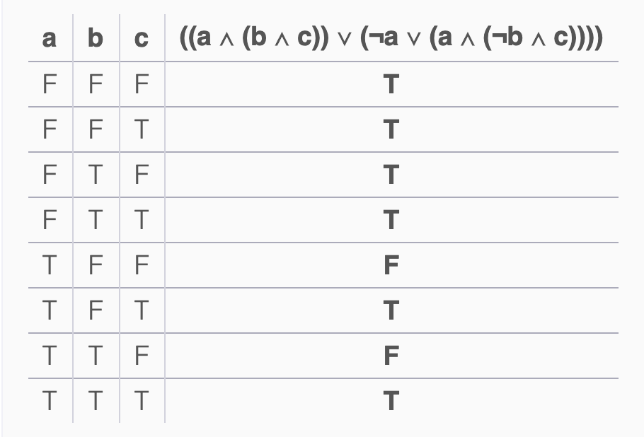

1. Consider the following rules for simplifying equations:

|  |  |  |
| --- | --- | --- |
| AND rules | OR rules | Name of rule |
| AB = BA | A+B=B+A | Commutative |
| AA=A | A+A=A | Idempotent |
| A • ¬A = 0 | A + ¬A = 1 | Complement |
| A • 1 = A | A + 0 = A | Identity |
| A • 0 = 0 | A + 1 = 1 | Annulment |
|  |  |  |
| ¬(¬A) = A |  | Double Negation |
| A(BC)=(AB)C | A+(B+C)=(A+B)+C | Associative |
| A(B+C)=AB+AC | A+BC=(A+B)(A+C) | Distributive |
| A+(AB)=A | A(A+B)=A | Absorptive 1 |
| A + (¬A • B) = A + B |  | Absorptive 2 |
| ¬(A + B) = ¬A • ¬B |  | DeMorgan’s 1 |
| ¬(A • B) = ¬A + ¬B |  | DeMorgan’s 2 |

We will use these rules to reduce the equation in part (a) to “¬A or C”.

Label each step with the rule used.

1. d = a•b•c + ¬a + a•¬b•c original equation
2. d = a•c•(b+¬b) + ¬a Idempotent
3. d = a•c•(1) + ¬a Compliment
4. d = ¬¬a•c + ¬a Identity
5. d = c + ¬a Absorptive 2
6. I built the original equation in b.i. above with a logic diagram simulator at <https://academo.org/demos/logic-gate-simulator/>:



When the simulator opens, a=b=c=0 because they are grey, but the output is 1 because it is yellow. There’s a video in the homework folder, here:

<https://www.dropbox.com/s/dwl46d5zva85c71/HW4P1c%20video.mov?dl=0>

In the video, I step through all possible permutations of a, b, and c, pausing for a moment between each. When a box turns yellow, it means I’ve clicked on it and set it to “1”. When I click again and it reverts to grey, it represents “0”.

Build a truth table for the simulation based on the movie. Your answers should match what you calculated in part “a” but will have a different order. Leave the final column blank.

|  |  |  |  |  |
| --- | --- | --- | --- | --- |
| A | B | C | d =a * b * c + ¬ a + a * ¬ b * c | d = c + ¬a |
| 0 | 0 | 0 | 1 | 1 |
| 0 | 0 | 1 | 1 | 1 |
| 0 | 1 | 0 | 1 |  |
| 0 | 1 | 1 | 1 |  |
| 1 | 0 | 0 | 0 | 0 |
| 1 | 0 | 1 | 1 | 1 |
| 1 | 1 | 0 | 0 |  |
| 1 | 1 | 1 | 1 |  |

1. Your task is now to create a circuit diagram using this tool for the simplified version of the equation: d = c + ¬a. You must have only two inputs, one for a and one for c. Copy and paste your resulting design here:

Finally, go back up to the table and fill in the values this circuit produces with just the two inputs, which is going to be for four rows only, when “ac” are 00, 01, 10 and 11. Leave the other rows blank for that last column.

1. (20 points) Cache Simulation – from lecture 23

Visit the block replacement simulator at this site: <http://www.ecs.umass.edu/ece/koren/architecture/Cache/frame1.htm>

Start with the following settings:

* Set the cache size to 32
* Set the # of Sets to 4
* Leave the Replacement Policy to LRU
* In another window go to <https://www.random.org/integers/> and generate 40 random integers between 0 and 64 in 1 column. They do not need to be unique among themselves; in other words, don’t worry if some are repeated. Your numbers must be different than everyone else’s in the course, so generate your own random sequence.
* Copy and the 40 integers you created and paste them into the box in the block replacement simulator
* Set Repeat to 3 cycles
* Turn off Limit Query at the bottom

1. (1 pts) Copy and paste your numbers that you used here. It must be text, not a scan or a screen capture; the TA needs to be able to copy and paste your numbers and reproduce your results.

23

50

19

60

49

52

57

48

61

38

55

35

29

15

10

61

64

39

31

60

1

44

20

16

43

9

63

54

43

6

28

10

57

53

37

0

3

61

20

11

1. (12 pts, ½ point per cell) Run the simulator by clicking on “Show Cache” and fill in the following table.

|  |  |  |  |  |
| --- | --- | --- | --- | --- |
| # of sets | Words per Set | Hit Rate Cycle 1 | Hit Rate Cycle 2 | Hit Rate Cycle 3 |
| 1 | 4 | .2 | .6 | .733 |
| 2 | 4 | .175 | .375 | .441 |
| 4 | 4 | .175 | .362 | .425 |
| 8 | 4 | .175 | .412 | .491 |
| 16 | 2 | .175 | .35 | .408 |
| 32 | 1 | .15 | .325 | .383 |

Next, download the spreadsheet attached to the homework – it is on Blackboard and on the Google Drive, named “Cache Simulator.xlsx”. There is also a google sheets version [here](https://docs.google.com/spreadsheets/d/1-IVvaTUFEyuWY2p9OghS9bSjSvRzp-qrKr4QkYNbw-o/edit#gid=320889537). These will open in read-only mode, so you can copy it to your own location to edit.

1. (1 pts) Transfer your answers from (a) into the table in the Cache Simulator spreadsheet and let the graph generate, and screen grab it and paste it below.

1. (1 pts) Take a screen snapshot of your browser window with the Block Replacement Simulator (that’s the web site). Insert it below. Take a picture with the # of sets = 8. The screen capture must show everything in the window – the settings and the results.

Answer the following questions:

1. (1 pt) Which # of Sets corresponds to a fully associative cache? 1
2. (1 pt) Which # of Sets corresponds to a direct-mapped cache? 32
3. (1 pt) What is as set called with 8 sets, each with 4 entries?

☐Direct-Mapped ☐4-way Set Associative ☐8-way Set Assoc. ☐Fully-Assoc.

1. (1 pt) What’s your highest hit rate? 73.3%
2. (1 pt) In terms of hit rates, what type of cache design is the winner?

_____ Direct-Mapped ______ Set Associative ______ Fully-Associative

*Here is an extended example:*

* I generated the following 40 random numbers:

74 89 60 24 97 63 77 63 75 41 47 23 22 42 13 46 20 47 20 88 95 33 65 21 71 58 79 19 100 2 10 60 58 52 70 10 34 4 74 77

* Here’s part of the table I filled out (I am leaving some cells blank):

|  |  |  |  |  |
| --- | --- | --- | --- | --- |
| # of sets | Words per Set | Hit Rate Cycle 1 | Hit Rate Cycle 2 | Hit Rate Cycle 3 |
| 1 |  | 20 | 60 | 73.33 |
| 2 |  | 17.5 | 35 | 40.83 |
| 4 |  | 17.5 | 43.75 | 52.5 |
| 8 |  | 17.5 | 42.5 | 50.83 |
| 16 |  | 17.5 | 28.75 | 32.5 |
| 32 |  | 17.5 | 32.5 | 37.5 |

* Here’s the graph I produced:



* Here’s a snapshot of one of the 3-cycle simulations:

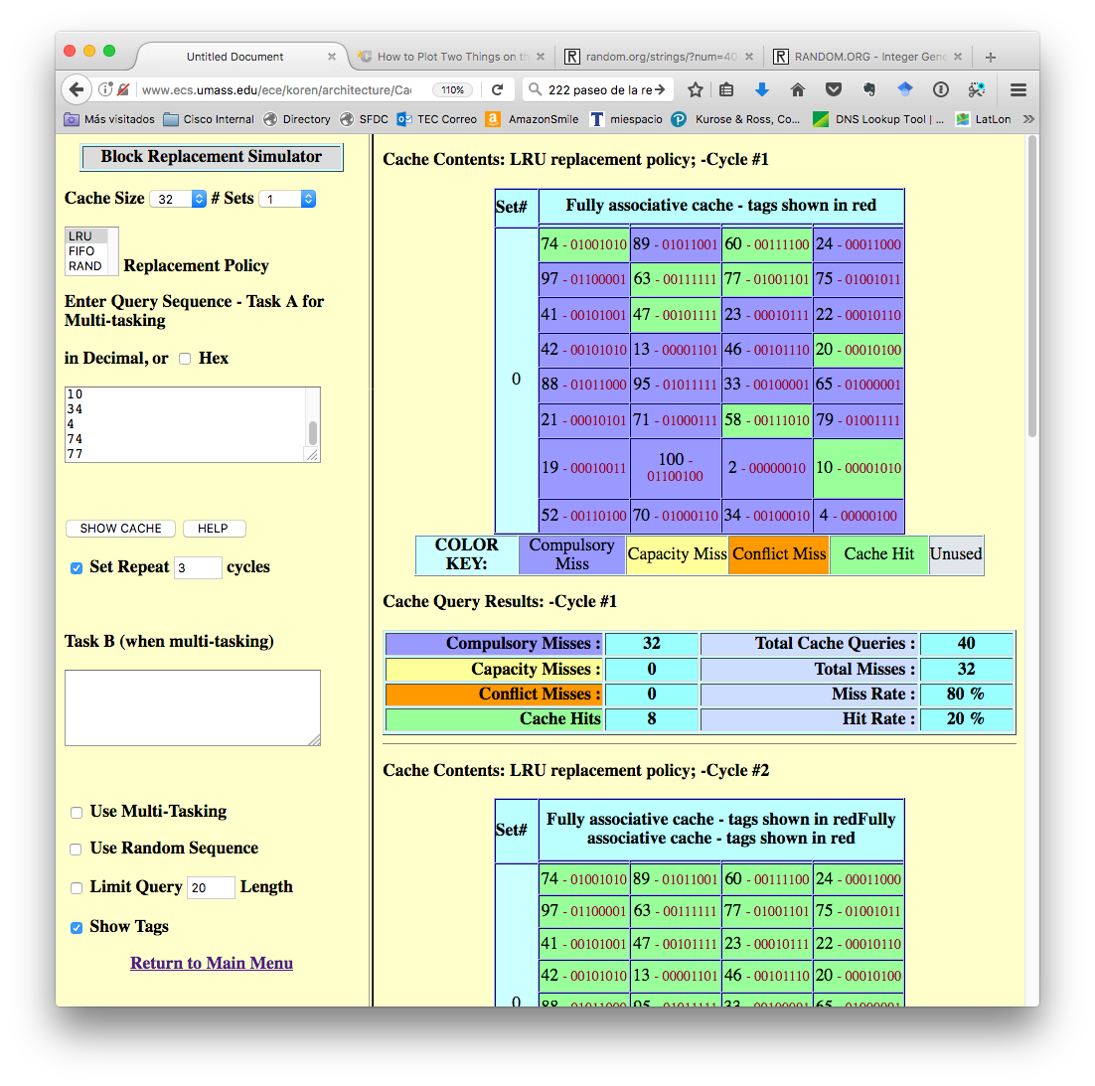

1. (20 pts) AMAT - Average Memory Access Time

Consider the cache system shown below. Memory access is sequential as discussed in lecture. Some quick definitions:

* **Isolated time** is the time required to search in that level of memory. It’s how fast that level is for a single search, and that speed never changes.
* **Cumulative time** is the total time spent searching for an item so far if it is ultimately found in the row you’re calculating. Just keep adding in the isolated time as you go.
* The **global hit rate** is the % of the time the answer is found in that category as a proportion of 100% of of the searches overall. There are other ways of calculating this, namely, the % out of the time left, but we’re not doing it that way. So the way to think of the way we’re doing it is as slices of a pie, where they have to all add up to 100% like this example. 93% of items are found in L1 cache, 5% in L2, and so on.
* The **weighted time** is the cumulative time multiplied by the global hit rate of the overall searches that are hits in that level. If 5% of the time you find an item in L2 and the cumulative time for L2 is 10ns, then on average it will add 10*.05=0.5ns to the overall average, so you’ll write “0.5” in the weighted time column.
* AMAT is the sum of weighted times.

(20 pts) Using this cumulative approach, complete the following table to calculate AMAT for a system with 5 levels of memory: 3 cache plus RAM and Disk.

|  |  |  |  |  |
| --- | --- | --- | --- | --- |
| Mem Hierarchy | Isolated Time (ns) | Cumulative Time (ns) | Global Hit Rate | Weighted Time (ns) |
| L1 Cache | 1 | 1 | 91.00% | .91 |
| L2 Cache | 2 | 3 | 6% | 0.18 |
| L3 Cache | 5 | 8 | 2.25% | .18 |
| RAM | 10 | 18 | 0.60% | .108 |
| Disk | 82 | 100 | 0.15% | .15 |
|  |  |  | AMAT | 1.528 |

1. (20 pts) RAID – from lecture 22
2. Which RAID level is best if you want to minimize the up-front investment in drives? Raid 0
3. Why not always use this level of RAID? Doesn’t have any extra disks incase one fails
4. At 47:44 of the lecture recording, we examine the difference between writes with RAID 4 and 5. What was the compelling reason for choosing 5 over 4 we discussed?

__ RAID 5 is better for large block sizes per write

__ RAID 5 improves performance by removing a bottleneck of parity writes

__ Leaving parity bits on 1 drive is risky – if you lose that drive you’re dead

1. Can all of the RAID versions survive a disk outage without permanent loss of data? Explain.

No. Not all produce a copy of the data

1. (20 pts) In Lecture 24 (coming up) we will review the Hamming Calculator.
2. Convert the last 2 digits of your student ID to an 8-bit binary number, and use it as the input into a Hamming table and show the parity bits and resulting 12-bit data you will transmit.

|  |  |  |  |  |  |  |  |  |  |  |  |  |  |  |
| --- | --- | --- | --- | --- | --- | --- | --- | --- | --- | --- | --- | --- | --- | --- |
| Preparing for Transmission | | | | | | | | | | | | | | |
|  |  | Data to Send | 00010010 | | | |  |  |  |  |  |  |  |  |
|  |  | bit position | p1 | p2 | d1 | p4 | d2 | d3 | d4 | p8 | d5 | d6 | d7 | d8 |
|  |  |  | 0 | 0 | 0 | 1 | 0 | 0 | 1 | 1 | 0 | 0 | 1 | 0 |
| Coverage Matrix | p1 | 0 | 0 |  | 0 |  | 0 |  | 1 |  | 0 |  | 1 |  |
| p2 | 0 |  | 0 | 0 |  |  | 0 | 1 |  |  | 0 | 1 |  |
| p4 | 1 |  |  |  | 1 | 0 | 0 | 1 |  |  |  |  | 0 |
| p8 | 1 |  |  |  |  |  |  |  | 1 | 0 | 0 | 1 | 0 |
| p16 |  |  |  |  |  |  |  |  |  |  |  |  |  |
| p32 |  |  |  |  |  |  |  |  |  |  |  |  |  |
| p64 |  |  |  |  |  |  |  |  |  |  |  |  |  |
| Data with Codes | | | **0** | **0** | **0** | **1** | **0** | **0** | **1** | **1** | **0** | **0** | **1** | **0** |

1. Calculate the last 4 digits of your student ID mod 12. What is that value?

2518 mod 12 = 10

Take the output from a, invert the bit in the position calculated above, and use that as input into the received data table. Show how the process correctly identifies the bit in error.

|  |  |  |  |  |  |  |  |  |  |  |  |  |  |  |
| --- | --- | --- | --- | --- | --- | --- | --- | --- | --- | --- | --- | --- | --- | --- |
| Checking Received Data for Errors | | | | | | | | | | | | | | |
|  |  | Data Received | 000100110010 | | | |  |  |  |  |  |  |  |  |
|  |  | bit position | p1 | p2 | d1 | p4 | d2 | d3 | d4 | p8 | d5 | d6 | d7 | d8 |
|  |  |  | 0 | 0 | 0 | 1 | 0 | 1 | 1 | 1 | 0 | 0 | 1 | 0 |
| Check Bits | c1 | 0 | 0 |  | 0 |  | 0 |  | 1 |  | 0 |  | 1 |  |
| c2 | 1 |  | 0 | 0 |  |  | 1 | 1 |  |  | 0 | 1 |  |
| c4 | 1 |  |  |  | 1 | 0 | 1 | 1 |  |  |  |  | 0 |
| c8 | 0 |  |  |  |  |  |  |  | 1 | 0 | 0 | 1 | 0 |
| c16 |  |  |  |  |  |  |  |  |  |  |  |  |  |
| c32 |  |  |  |  |  |  |  |  |  |  |  |  |  |
| c64 |  |  |  |  |  |  |  |  |  |  |  |  |  |
|  | Bit in Error | 6 |  |  |  |  |  |  |  |  |  |  |  |  |
| Data with Codes | | | **0** | **0** | **0** | **1** | **0** | **1** | **1** | **1** | **0** | **0** | **1** | **0** |
| Corrected Byte | | | 000100110010 | | | |  |  |  |  |  |  |  |  |